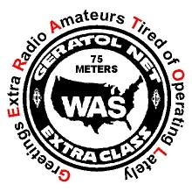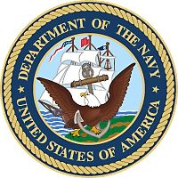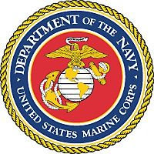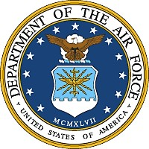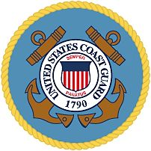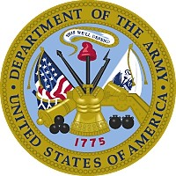

Has submitted satisfactory evidence of 2 way SSB contacts in the Extra Class portion of the 80 meter phone band with 240 U.S. Military Veterans. This represents a QSO with one member or former member of each branch of service in the 48 contiguous United States

*This accomplishment bears tribute to those who have unselfishly given of themselves to protect and defend the United States of America*

**Dave Ertel**

**XX/XX/XXXX**

**XXXX**

**Awards Manager KJ8V**

**Certificate #**

**Date:**

**SAMPLE**

**GERATOL NET**

**SALUTE TO VETERANS AWARD**